Lavori di Educazione Civica – inglese – classe 5A LSA

A comparative analysis of work-related deaths and serious injuries in Italy and the UK.

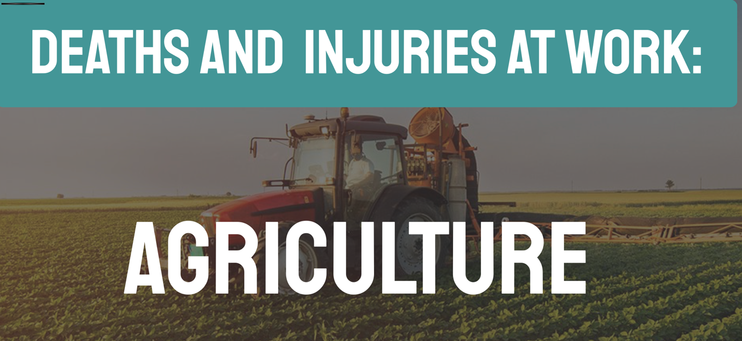

https://view.genially.com/69578f9965924c7731816c99/presentation-agriculture

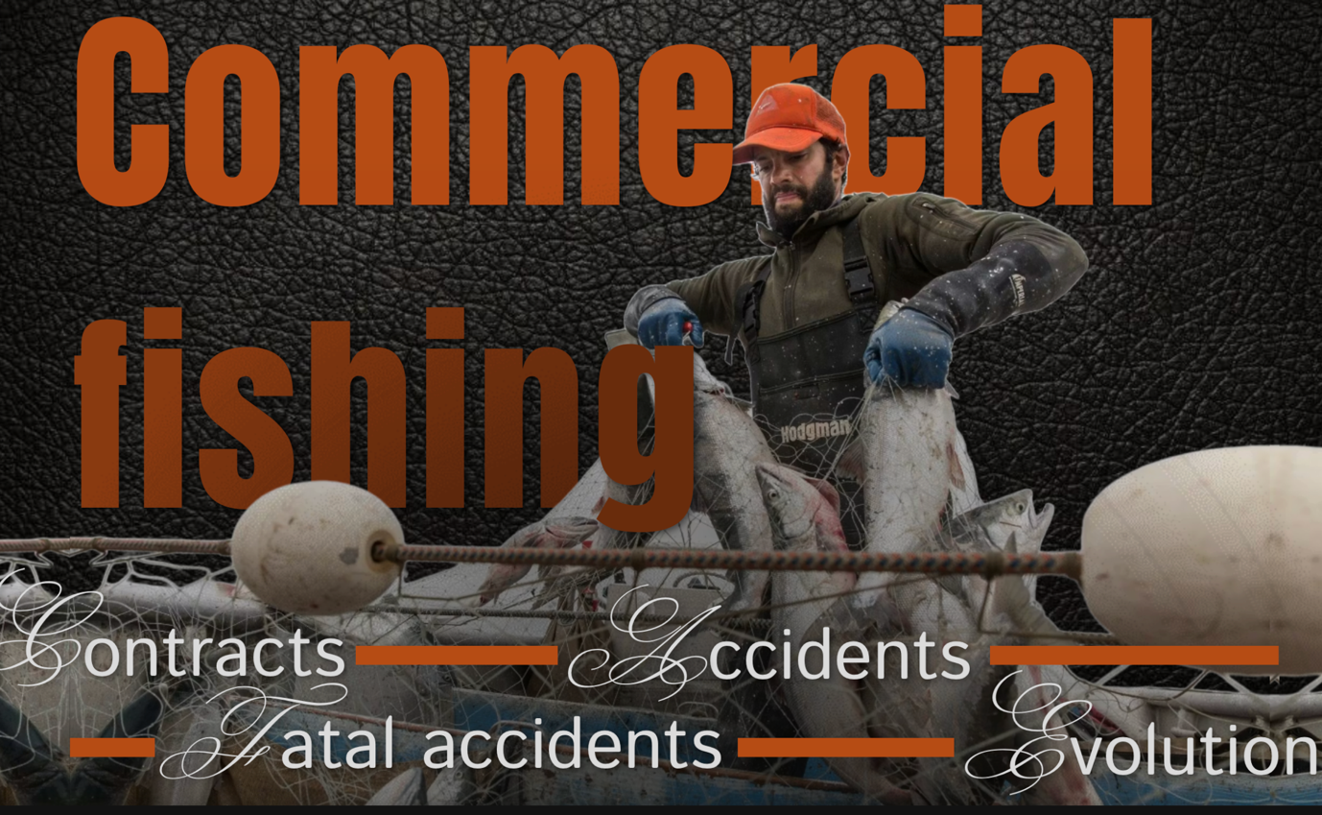

https://view.genially.com/695a93837e4a6b4bdbfa9f5d/presentation-attis pesca

